**The Tale of two cities**

**Introduction**-

The Tale of two cities is a project designed to pick out the similarities in the neighborhoods of two cities. This program uses foursquare API to solve this problem. The same colored clusters are the neighborhoods which belong to the same categories.

Interest-

This program is designed to help people in the US or any other parts of the world to compare the similarities between two cities. Its target audience is the people who are trying to move from one city to another. The people who are afraid that the different city and the different neighborhood they may move in, might be totally different from their existing neighborhood. If people have been living somewhere for a while it becomes their comfort zone, and moving into an area which was like their previous one might make them more comfortable and ease the process of settling in. The program uses the resemblance of the venues located near a neighborhood in one city and compares it to another city and find the same distribution of the venues in the other city.

Data sources -

I have used the foursquare data to explore the input neighborhoods and classify them into similar clusters and the areas which are similar. The Same colored clusters are the neighborhoods which belong to the same categories.

Feature Selection-

The model uses the categories of data provided by the foursquare API. The application finds the popular places located near a particular neighborhood. Distributes them into categories and helps find the similar categories in the place selected to move.

Data Segmentation-

The data is Segmented into binary encoding, also known as one hot encoding to fit the data into the k means algorithm fast and will give much accurate results.

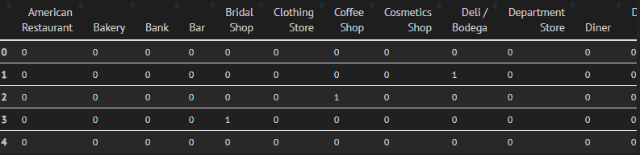

As you can see all the places are converted in form of a dataframe and then fit into the k means algorithm which will follow this step.

Clustering-

K means clustering is used for this feature to find the similar cluster areas. The k-means algorithm takes the similar types of places in a particular area and clusters them into similar groups. The K means Algorithm uses k points around which the data is clustered. Then the points are moves to minimize the inter-data point distance and maximize the inter-point distance.

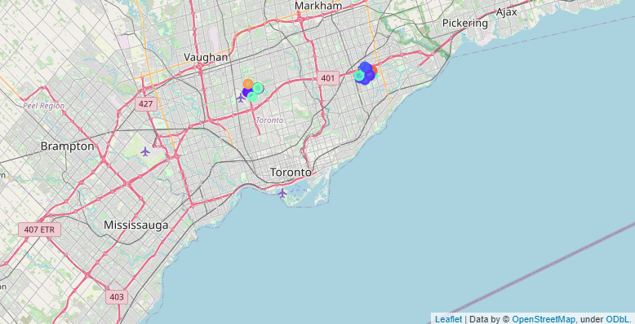

The areas with the similar color are the ones with similar colors are the neighborhoods with similar characteristics, in the different regions.

Limitations-

The logarithm is based on the Foursquare API so it can only access the locations thoroughly explored by the foursquare. If the place you entered returns less than at least less than 50 values by the Foursquare then the algorithm might not be able to categorise places correctly.

Conclusion-

The algorithm can predict any two matching neighborhoods and can help people find their new home fast.